Welcome to the YKSS 2026 AGM and thank you for attending and supporting the Society.

2025 was a successful year for our organization in terms of maintaining our programming and ensuring we met our goal of enhancing and supporting the lives of Yellowknife Seniors.
The Social Committee delivered several fun events, and we look for a continuation in 2026.

The PR Committee produced high quality newsletters.

The Advocacy Committee continues to bring forward issues that directly affect our seniors on a day-to-day basis.

We did fall short on the fundraising side of our operation. The Board will address this situation in 2026.

The Board works very hard to meet the goals and objectives of the Society and I congratulate those members whose terms are now fulfilled: Hal Logsdon, Terry Hawkins, Diane Dempsey, Donna Gibson and Marilyn Jordan.

Board members entering the second half of their 2-year terms are Bev Bourque, Mieke Cameron, Effie Brown, and Jill Christensen.

Wendy Bisaro, Past President, also serves on the board and is a positive contributor to our work even from afar.

An important revenue source for the Society is the rental of space in the Baker Centre. The responsibility for keeping this building a desirable location is in the hands of Kimberly Doyle, our Executive Director and authority on all things senior-related. We are grateful for the outstanding job she does.

There are many people to thank for the successful operation of the Society, and these are the volunteers who help with LWAB, ticket sellers, exercise classes and special events. Volunteers contribute to the on-going vitality of our Society.

Sincerely

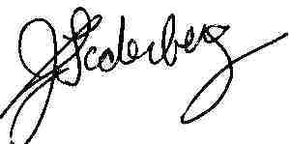
John Soderberg
President

